|  |  |  |  |  |  |
| --- | --- | --- | --- | --- | --- |
| Date | 9-Dec-22 | | | Tester Name | Janette Paus |
| Environment | Penfax - Test 2 | | | Login used | <If different from the Tester> |
| Operating System | Windows | Version: 21H2 | Update Number: | | |
| Software Used | Select Software | Version: 107.0.1418.56 | Update Number: | | |
| Select Software | Version: | Update Number: | | |
| Application Release version | R22.4.1 | | | | |
| Test Case Title | E20.10 | | | | |
| Test Type | Regression | | | | |
| Test Scenario | Process a Unit Adjustment (positive and negative) | | | | |
| Expected Results | Unit adjustment processes and completes overnight & check that the funds are reflected in the account balance.  That a unit adjustment done other than the current date has breakage correctly attached. | | | | |
| Pass/Fail | Pass | | | JIRA# |  |

Search for active PEPP member

SID: 248477

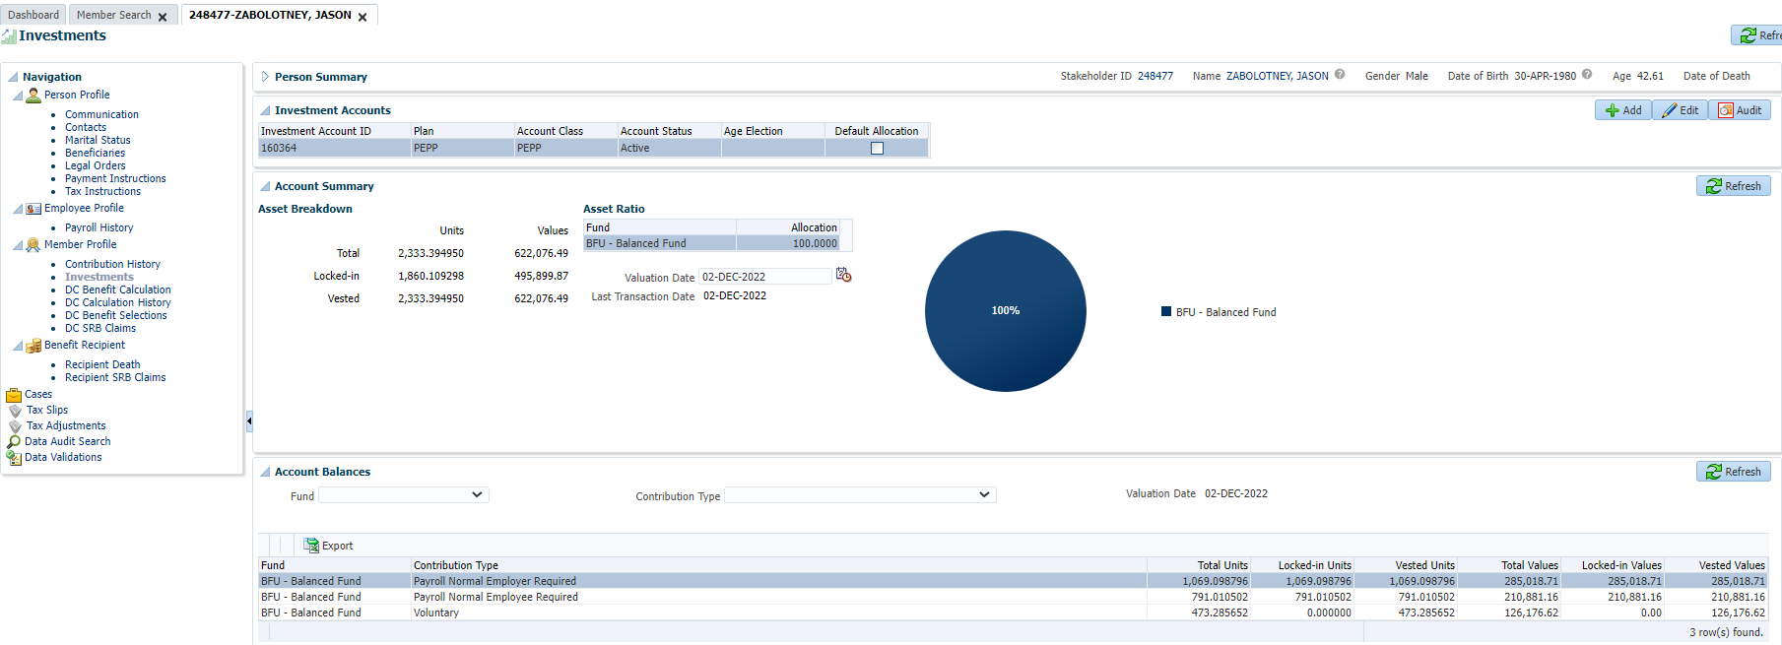

Taking all the units from voluntary and moving to EE required. Processed adjustment:

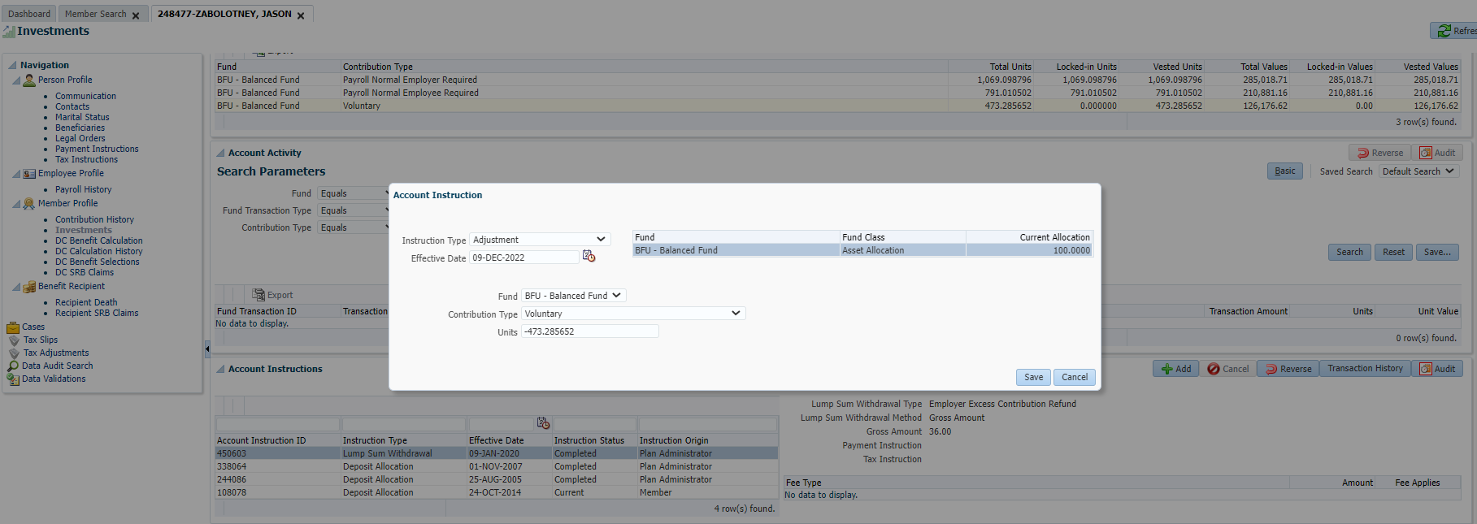

Processed adjustment #2:

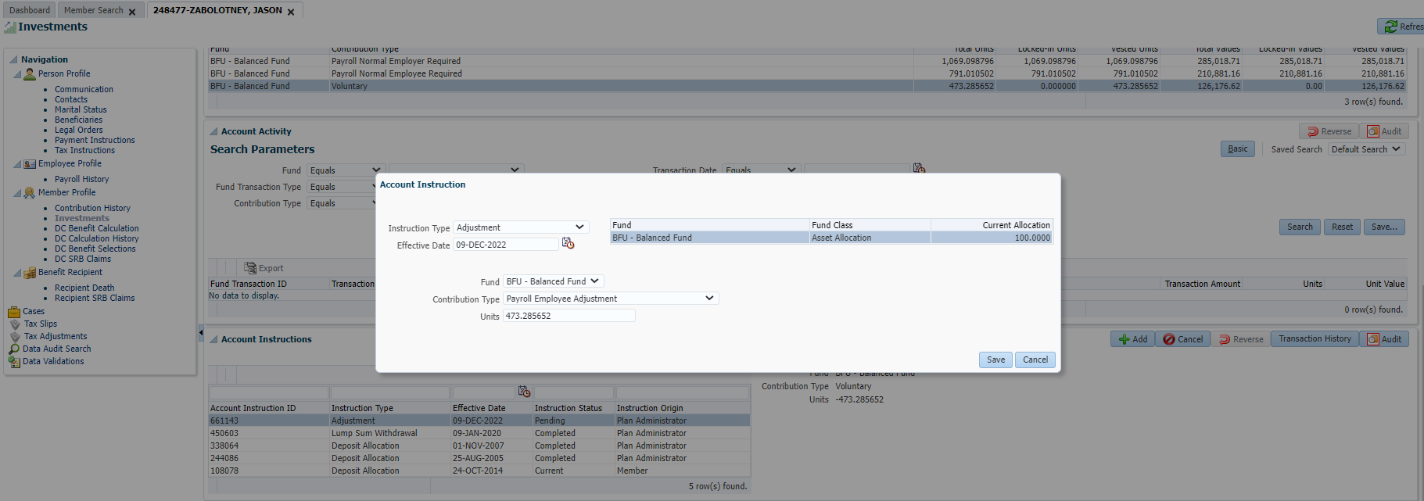

Both transactions are showing as pending, will confirm next day.

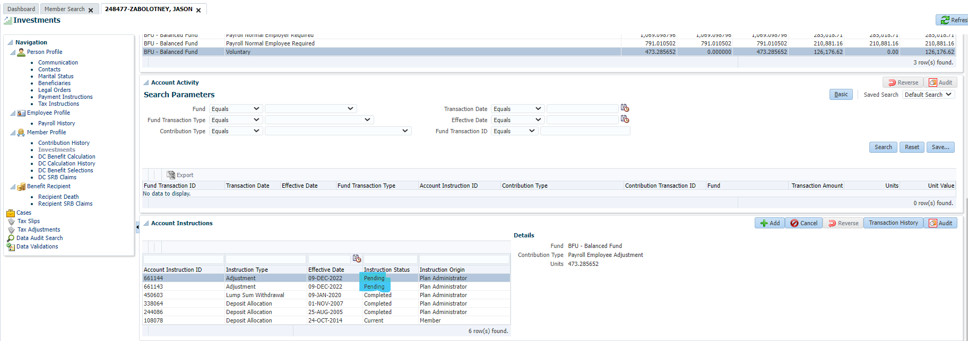

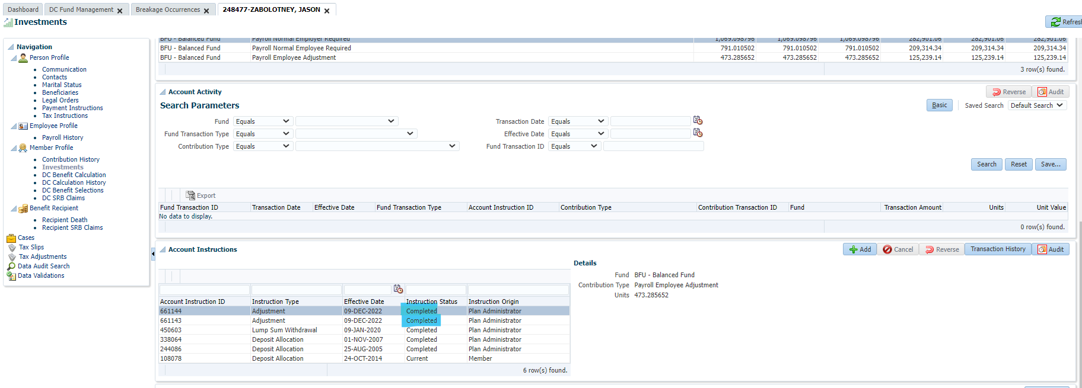

1. Money moved from VOL to EE

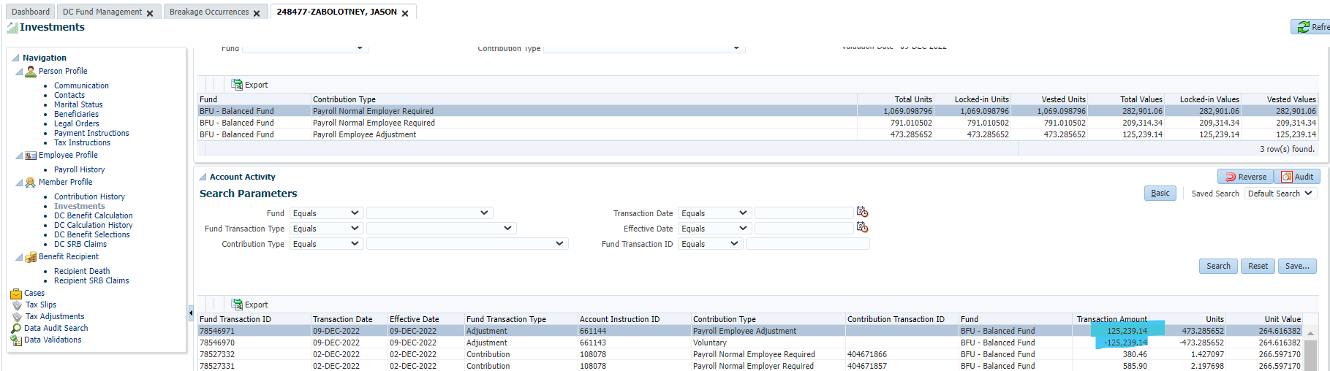

1. There is no breakage (+ and – units match)

